**--Use git to upload your file to github:**

**The following is the commands:**

1

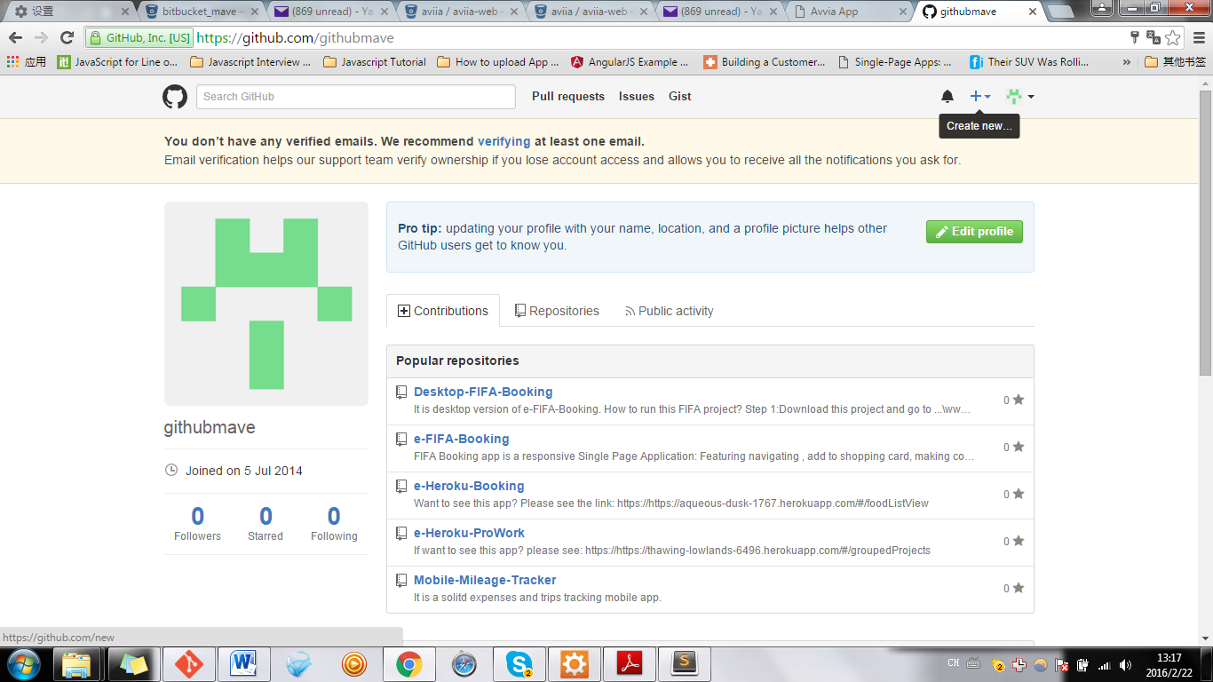

2.

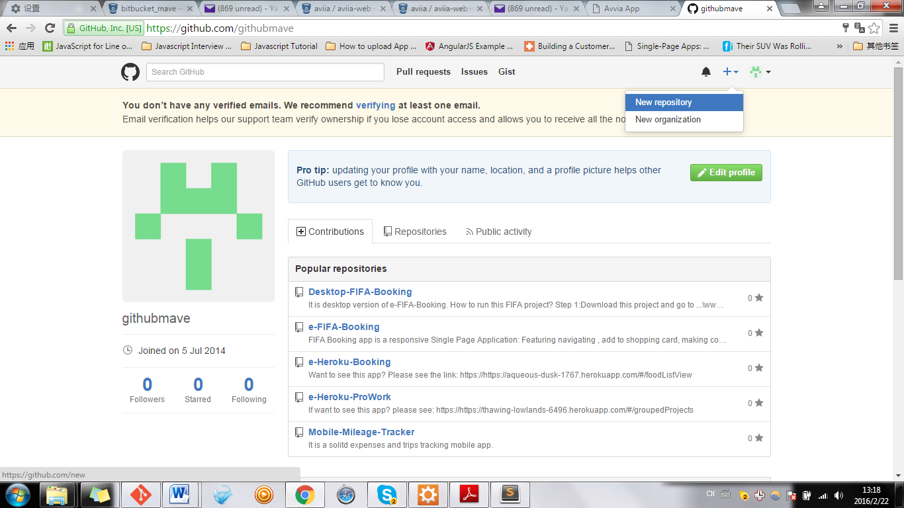

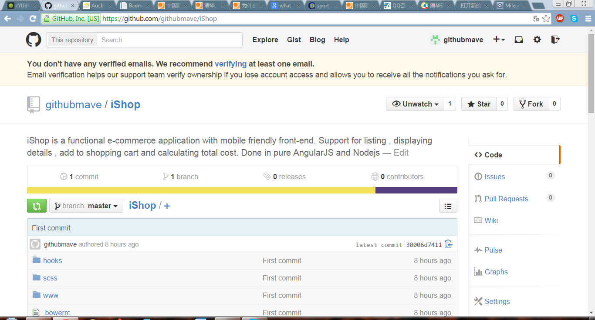

Click on top right hand of the screen “+”: create a new repository

**(Pls. note: you must sign in to add repository)**

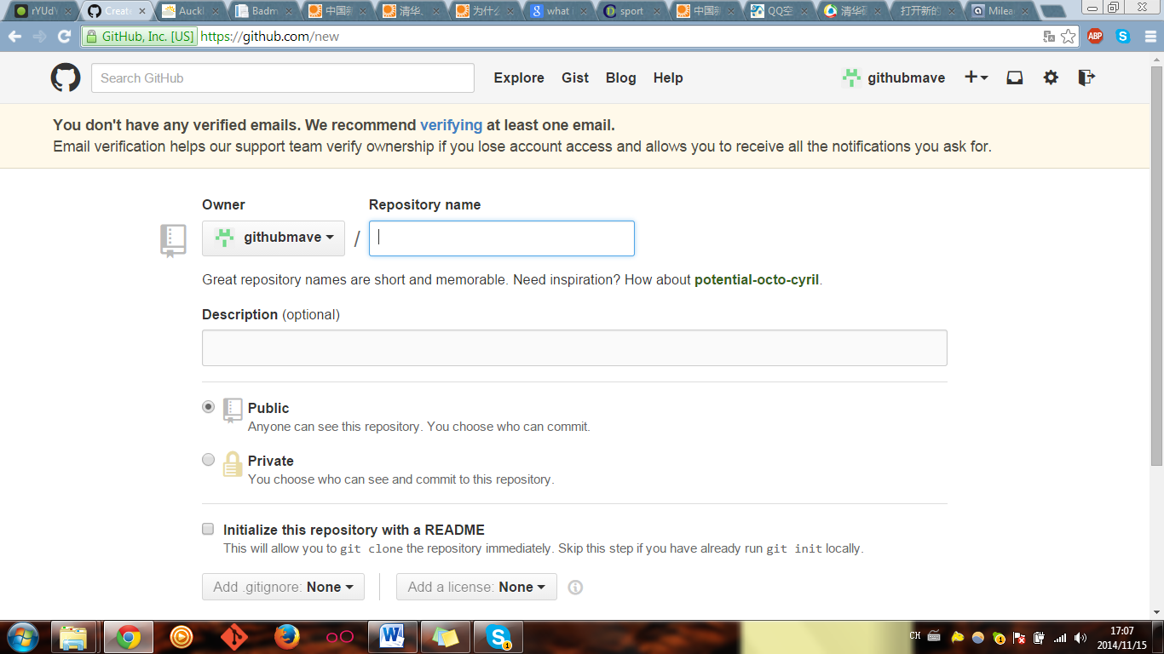

Type your new repository

Welcome to Git (version 1.9.4-preview20140929)

Run 'git help git' to display the help index.

Run 'git help <command>' to display help for specific commands.

mave@MAVE-PC ~

**$ cd ionic-app-base**

mave@MAVE-PC ~/ionic-app-base

$ git clone https://github.com/githubmave/iShop.git

Cloning into 'iShop'...

warning: You appear to have cloned an empty repository.

Checking connectivity... done.

mave@MAVE-PC ~/ionic-app-base

**$ cd iShop**

**(move all fies in ionic-login-base into iShop , then type “ git add .” )**

mave@MAVE-PC ~/ionic-app-base/iShop (master)

1. **$ git add .**

**Or $ git add --all**

warning: LF will be replaced by CRLF in www/lib/ionic/css/ionicons.css.

The file will have its original line endings in your working directory.

warning: LF will be replaced by CRLF in www/lib/ionic/css/ionicons.min.css.

The file will have its original line endings in your working directory.

warning: LF will be replaced by CRLF in www/lib/ionic/js/ngstorage/.bower.json.

The file will have its original line endings in your working directory.

**mave@MAVE-PC ~/ionic-app-base/iShop (master)**

1. **$ git commit -m 'First commit'**

[master (root-commit) 30006d7] First commit

warning: LF will be replaced by CRLF in www/lib/ionic/css/ionicons.css.

The file will have its original line endings in your working directory.

warning: LF will be replaced by CRLF in www/lib/ionic/css/ionicons.min.css.

The file will have its original line endings in your working directory.

warning: LF will be replaced by CRLF in www/lib/ionic/js/ngstorage/.bower.json.

The file will have its original line endings in your working directory.

109 files changed, 121830 insertions(+)

create mode 100644 .bowerrc

create mode 100644 .gitignore

create mode 100644 HelloCordova-release-unsigned.apk

create mode 100644 Mile_joy_133.apk

create mode 100644 README.md

create mode 100644 bower.json

create mode 100644 config.xml

create mode 100644 desktop.ini

create mode 100644 gulpfile.js

create mode 100644 hooks/README.md

create mode 100644 hooks/after_prepare/010_add_platform_class.js

create mode 100644 ionic.project

create mode 100644 my-release-key.keystore

create mode 100644 package.json

create mode 100644 scss/ionic.app.scss

create mode 100644 www/.gitignore

create mode 100644 www/config.xml

create mode 100644 www/desktop.ini

create mode 100644 www/index.html

create mode 100644 www/js/app.js

create mode 100644 www/lib/ionic/css/app.css

create mode 100644 www/lib/ionic/css/bootstrap-combined.min.css

create mode 100644 www/lib/ionic/css/ionic.css

create mode 100644 www/lib/ionic/css/ionic.min.css

create mode 100644 www/lib/ionic/css/ionicons.css

create mode 100644 www/lib/ionic/css/ionicons.min.css

create mode 100644 www/lib/ionic/fonts/ionicons.eot

create mode 100644 www/lib/ionic/fonts/ionicons.svg

create mode 100644 www/lib/ionic/fonts/ionicons.ttf

create mode 100644 www/lib/ionic/fonts/ionicons.woff

create mode 100644 www/lib/ionic/js/angular-ui/angular-ui-router.js

create mode 100644 www/lib/ionic/js/angular-ui/angular-ui-router.min.js

create mode 100644 www/lib/ionic/js/angular/angular-animate.js

create mode 100644 www/lib/ionic/js/angular/angular-animate.min.js

create mode 100644 www/lib/ionic/js/angular/angular-resource.js

create mode 100644 www/lib/ionic/js/angular/angular-resource.min.js

create mode 100644 www/lib/ionic/js/angular/angular-sanitize.js

create mode 100644 www/lib/ionic/js/angular/angular-sanitize.min.js

create mode 100644 www/lib/ionic/js/angular/angular.js

create mode 100644 www/lib/ionic/js/angular/angular.min.js

create mode 100644 www/lib/ionic/js/ionic-angular.js

create mode 100644 www/lib/ionic/js/ionic-angular.min.js

create mode 100644 www/lib/ionic/js/ionic.bundle.js

create mode 100644 www/lib/ionic/js/ionic.bundle.min.js

create mode 100644 www/lib/ionic/js/ionic.js

create mode 100644 www/lib/ionic/js/ionic.min.js

create mode 100644 www/lib/ionic/js/ngstorage/.bower.json

create mode 100644 www/lib/ionic/js/ngstorage/.bowerrc

create mode 100644 www/lib/ionic/js/ngstorage/.gitignore

create mode 100644 www/lib/ionic/js/ngstorage/CHANGELOG.md

create mode 100644 www/lib/ionic/js/ngstorage/Gruntfile.js

create mode 100644 www/lib/ionic/js/ngstorage/LICENSE

create mode 100644 www/lib/ionic/js/ngstorage/README.md

create mode 100644 www/lib/ionic/js/ngstorage/bower.json

create mode 100644 www/lib/ionic/js/ngstorage/ngStorage.js

create mode 100644 www/lib/ionic/js/ngstorage/ngStorage.min.js

create mode 100644 www/lib/ionic/js/ngstorage/package.json

create mode 100644 www/lib/ionic/js/ngstorage/test/spec.js

create mode 100644 www/lib/ionic/scss/_action-sheet.scss

create mode 100644 www/lib/ionic/scss/_animations.scss

create mode 100644 www/lib/ionic/scss/_backdrop.scss

create mode 100644 www/lib/ionic/scss/_badge.scss

create mode 100644 www/lib/ionic/scss/_bar.scss

create mode 100644 www/lib/ionic/scss/_button-bar.scss

create mode 100644 www/lib/ionic/scss/_button.scss

create mode 100644 www/lib/ionic/scss/_checkbox.scss

create mode 100644 www/lib/ionic/scss/_form.scss

create mode 100644 www/lib/ionic/scss/_grid.scss

create mode 100644 www/lib/ionic/scss/_items.scss

create mode 100644 www/lib/ionic/scss/_list.scss

create mode 100644 www/lib/ionic/scss/_loading.scss

create mode 100644 www/lib/ionic/scss/_menu.scss

create mode 100644 www/lib/ionic/scss/_mixins.scss

create mode 100644 www/lib/ionic/scss/_modal.scss

create mode 100644 www/lib/ionic/scss/_platform.scss

create mode 100644 www/lib/ionic/scss/_popover.scss

create mode 100644 www/lib/ionic/scss/_popup.scss

create mode 100644 www/lib/ionic/scss/_progress.scss

create mode 100644 www/lib/ionic/scss/_radio.scss

create mode 100644 www/lib/ionic/scss/_range.scss

create mode 100644 www/lib/ionic/scss/_reset.scss

create mode 100644 www/lib/ionic/scss/_scaffolding.scss

create mode 100644 www/lib/ionic/scss/_select.scss

create mode 100644 www/lib/ionic/scss/_slide-box.scss

create mode 100644 www/lib/ionic/scss/_split-pane.scss

create mode 100644 www/lib/ionic/scss/_tabs.scss

create mode 100644 www/lib/ionic/scss/_toggle.scss

create mode 100644 www/lib/ionic/scss/_type.scss

create mode 100644 www/lib/ionic/scss/_util.scss

create mode 100644 www/lib/ionic/scss/_variables.scss

create mode 100644 www/lib/ionic/scss/ionic.scss

create mode 100644 www/lib/ionic/scss/ionicons/_ionicons-animation.scss

create mode 100644 www/lib/ionic/scss/ionicons/_ionicons-font.scss

create mode 100644 www/lib/ionic/scss/ionicons/_ionicons-icons.scss

create mode 100644 www/lib/ionic/scss/ionicons/_ionicons-variables.scss

create mode 100644 www/lib/ionic/scss/ionicons/ionicons.scss

create mode 100644 www/lib/ionic/version.json

create mode 100644 www/lib/pouchdb/dist/pouchdb.js

create mode 100644 www/templates/countCost.html

create mode 100644 www/templates/endMeter.html

create mode 100644 www/templates/endPoint.html

create mode 100644 www/templates/genreport.html

create mode 100644 www/templates/history.html

create mode 100644 www/templates/historyDetails.html

create mode 100644 www/templates/purpose.html

create mode 100644 www/templates/setCar.html

create mode 100644 www/templates/splash.html

create mode 100644 www/templates/startMeter.html

create mode 100644 www/templates/startPoint.html

mave@MAVE-PC ~/ionic-app-base/iShop (master)

1. **$ git remote add origin https://github.com/githubmave/iShop.git**

fatal: remote origin already exists.

mave@MAVE-PC ~/ionic-app-base/iShop (master)

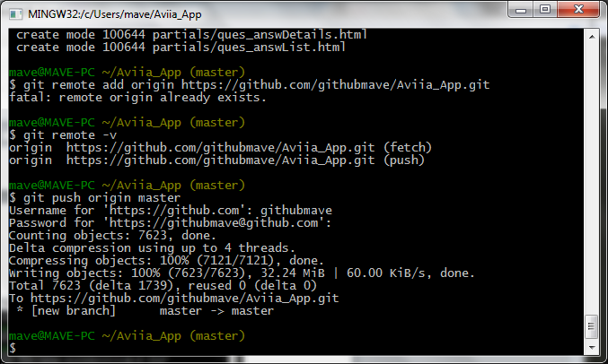

1. **$ git remote -v**

origin https://github.com/githubmave/iShop.git (fetch)

origin https://github.com/githubmave/iShop.git (push)

mave@MAVE-PC ~/ionic-app-base/iShop (master)

1. **$ git push origin master**

Username for 'https://github.com': githubmave

Password for 'https://githubmave@github.com':bigo6910

Counting objects: 129, done.

Delta compression using up to 4 threads.

Compressing objects: 100% (118/118), done.

Writing objects: 100% (129/129), 4.54 MiB | 66.00 KiB/s, done.

Total 129 (delta 11), reused 0 (delta 0)

To https://github.com/githubmave/iShop.git

* [new branch] master -> master

mave@MAVE-PC ~/ionic-app-base/iShop (master)

$